Name:
Institution:
Tutor:
Date:
Project Supervision
According to the contract document, for a project to be completed within the stipulated time, there are usually many things that involve more than a person that always comes into play. The coming into action of all these aspects of works usually fall under one area of specialization, and that is Project supervision. Project supervision is the process that entails monitoring the project to ensure the project is built as stipulated in the design. The project supervisor who is tasked with the supervisory work is responsible for the safety and health of the project's design elements from planning to conclusion.
The scope of works for project supervision cuts typically across the different departments involved in ensuring that a project is a success. Ensuring that all the resources required to execute the project are in place before the project commencement is a key aspect of project supervision. After that has been settled, the project supervisor now ensures that the project's design is safe both during the construction stages and when it is in use after completion. Project supervision is also tasked with preparing a preliminary safety and health plan to be used during the construction stage. The plan outlines ways to reduce design risks in the construction phase of the project. The supervision also entails coordinating the design of the build with permanent and temporary works designers. At the end of the project, the project supervisor prepares the safety file to give to the client. By identifying, eliminating, or reducing potential safety and health risk, the project supervision role is vital in ensuring all involved in the project during the construction and the project's future life.

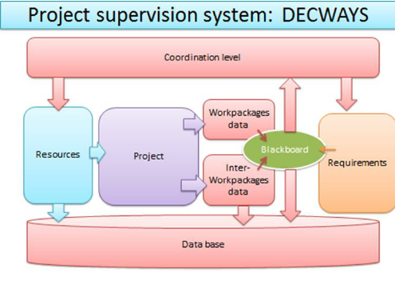
Fig 1: Project supervision structure

